HO CHI MINH CITY UNIVERSITY OF TECHNOLOGY

**FACULTY OF COMPUTER SCIENCE AND ENGINEERING**



PROJECT REPORT

PRACTICE ON SOFTWARE ENGINEERING

**RESTAURANT POS 2.0**

Lecturer: Assoc. Prof. Quan Thanh Tho

| Tran Duc Thien | 1952998 |
| --- | --- |
| Ly Kim Phong | 1952916 |
| Tran Quoc Hoan | 1952051 |
| Nguyen Thanh Chuong | 1952595 |
| Le Thanh Dinh | 1952027 |

Contents

***Task 1***: 3

*Context:* 3

Requirements: 3

*Food ordering* 6

Task 2: 8

Task 2.1: Draw an activity diagram to capture Major functional requirements of the desired system. 8

Task 2.2: Draw a sequence diagram for use-case in Task 1.3 12

Task 2.3. Draw a class diagram 14

Task 3: 19

Task 3.1: 19

Task 3.2: 21

Changelog 26

Reference 26

## ***Task 1***:

##### *Context:*

* The POS or point of sale is when and where customers select something, add to cart and then check out for payment.
* At the point of sale, the merchant calculates the amount owed by the customer, indicates that amount, may prepare an invoice for the customer, and allows the customer to make payment(cash/credit card/apps).
* In the Sar-Cov-2 pandemic, indirect contact is advised, PoS application should be promoted to reduce the number of times a waiter has to face to face communicate with the customers, which is beneficial for both sides.
* PoS system allows for ordering process, feedback, status notification when the restaurant has menu updates or other information and credit card payment transaction (online/offline).
* Such systems are expected to increase business intelligence, reduce wasted effort and the opportunity to scale as the business grows.

=> So we decided to build a responsive Web app to serve the largest number of guests, ease of use and easy to maintain.

Relevant stakeholders: Customers, Res Owner, Clerks, Chefs.

Jobs: Display menu, meal select, remove from stock, order (placing, confirm, process, reject, deliver), waiting queue(food is done or not), feedback, logging order, paying methods (online(credit, third-party app) & cash).

Scope: 300 customers/day, serve 8am-10pm, 21 cus/hour, 1-2 orders at the same time, 1 restaurant.

##### Requirements:

Functional:

View list of restaurant: customer can see the list of available restaurants of the owner as well as the address(if to be scaled).

View menu: customer can see the menu of the restaurant, updated to the minute.

Placing order: customer can ordering food include search food they want and select it

View list of order: customers can preview the food they have chosen before ordering and payment.

Notifications of order: customers can know whether the course is being made or cancelled.

Feedback: After eating food at the restaurant or at home, customer can feedback about the food on the website

Non functional:

Usability: The system should allow non-direct contact between Clerks and Customers. Moreover, right on the menu page will have information on the status of food reviews.

User interface: The system should be implemented using Web technology and QR code, so customers will not have to install apps. The website should be responsive so that it can be displayed on different devices.

Scalability: The system should be extendable to use in multiple restaurants in the future. Capacity: The current transactions are about 300 orders per day.

Serviceability: The quality of being able to provide good services, high responsive interaction, and customers can give feedback on their experience to the clerk for better customer service.

Feedback: Multiple choice form for customers to check the quality of services, additional feedback and complaints. May update the system to post food reviews and critics later if time allows.

Security: When the user makes payment, the system is not allowed to store credit/debit card information of the user.

Maintainability: The web must be easy to maintenance, avoiding DDOS attacking from competitive services.

Ver 1: 18/9/2021(deleted)

Ver 2: 23/9/2021([link](https://viewer.diagrams.net/?page-id=Hcg7Q0vDsgE8VdpAob2g&highlight=0000ff&edit=_blank&layers=1&nav=1#G1Mt8L0EeDxM_pB8qi_fikuVrxQIUpPcJg))

Ver 3: 07/10/2021([link](https://viewer.diagrams.net/?page-id=pXoU4k3pK258AMGFvbBh&highlight=0000ff&edit=_blank&layers=1&nav=1&page-id=pXoU4k3pK258AMGFvbBh#G1Mt8L0EeDxM_pB8qi_fikuVrxQIUpPcJg), below)

##### *Food ordering*

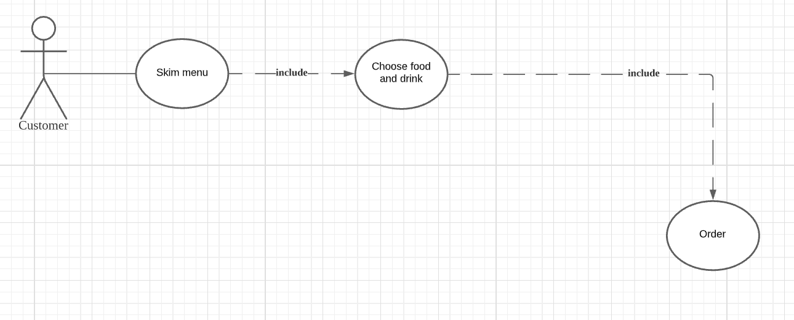

| Name | Food ordering |
| --- | --- |
| Actor | Customers |
| Description | When ordering food, people can skim through the menu choosing their food and drink. After that they can order the food and wait until the dishes are ready. They can return to the menu to order new food. |
| Preconditions | Customers need to access the home page. |
| Normal flow | 1. Customers go to the home page by URL or QR code.  2. Customers can search for the desired food and drink on the menu.  3. Customers put the food and drink they want in the cart.  4. Customers make the order so the restaurant can prepare the dish.  5. Customers are back to the menu to continue skimming. |
| Exceptions | Exception at step 4: Customers want to choose more food and drink before ordering. |
| Alternative flow | Customers can go back to step 2 |

## Task 2:

#### Task 2.1: Draw an activity diagram to capture Major functional requirements of the desired system.

[Link to the diagram.](https://viewer.diagrams.net/?page-id=e7e014a7-5840-1c2e-5031-d8a46d1fe8dd&highlight=0000ff&edit=_blank&layers=1&nav=1&hide-pages=1#G1662ygfhhLBS8YC1OaAdpUHDNAeFx4APS)

| Name | Reservation |
| --- | --- |
| Actor | Customers, Clerks |
| Description | Customers can view the list of available restaurants. They can pick a restaurant to make a reservation, and this will be confirmed by the clerk later. |
| Preconditions | Customers need to access the home page. |
| Normal flow | 1. Customers view the list of restaurants.  2. Customers choose to view a specific restaurant.  3. Customers make a reservation  4. The clerk will confirm the customer’s reservation |
| Exceptions | Exception 1: at step 1: If there is no restaurant .  Exception 2: at step 2: If there is only 1 restaurant .  Exception 3: at step 3: If there’re more than 1 restaurant and the customer get rejected. |
| Alternative flow | For exception 1, 2: the system will display “No restaurant is available.  For exception 3: customers can go back to step 2. |

| Name | Food ordering |
| --- | --- |
| Actor | Customers, Clerks, Chefs |
| Description | When ordering food, people can skim through the menu choosing their food and drink. After that they can order the food and wait until the dishes are ready. They can return to the menu to order new food. |
| Preconditions | Customers need to access the home page. |
| Normal flow | 1. Customers go to the home page by URL or QR code and the system will show the menu.  2. Customers can search for the desired food and drink on the menu.  3. Customers put the food and drink they want in the cart.  4. Customers make the order so the restaurant can prepare the dish.  5. The clerks will check the order and notify the chef.  6. The chefs will check for stock and prepare the dish.  7. The clerks will notify the food is ready and serve the dish.  8. The clerks make the bill.  9. The customers pay the bill.  10. The clerk will return the changes if any.  11. The customers give feedback. |
| Exceptions | Exception 1: at step 4: the customers want more food before ordering.  Exception 2: at step 6: the dish is out of stock. |
| Alternative flow | For exception 1: Customers can go back to step 2.  For exception 2:  the clerks will mark the course and customers go back to step 2. |

| Name | Make changes |
| --- | --- |
| Actor | Restaurant owner |
| Description | The owner wants to make some adjustments to the menu and include a new restaurant into the system. |
| Preconditions | The restaurant owner needs to access the home page. |
| Normal flow | 1. The restaurant owner logs in.  2. The restaurant owner will check if there are changes to be made.  3. The restaurant owner adds items to the menu, deletes items from menu, edits price, adds new restaurant. |
| Exceptions | At step 3, the owner is not satisfied with the change made. |
| Alternative flow | The restaurant owner can go back to step 2. |

#### Task 2.2: Draw a sequence diagram for use-case in Task 1.3

In this case, a food ordering diagram.

[Link to the diagram.](https://viewer.diagrams.net/?page-id=9361dd3d-8414-5efd-6122-117bd74ce7a7&highlight=0000ff&edit=_blank&layers=1&nav=1#G1pTpbitxA0Cyh5wxYQcxVh10cBTaO7Ns3)

| Name | Food ordering |
| --- | --- |
| Actor | Customers |
| Description | When ordering food, people can skim through the menu choosing their food and drink. After that they can order the food and wait until the dishes are ready. They can return to the menu to order new food. |
| Preconditions | Customers need to access the home page. |
| Normal flow | 1. Customers go to the home page by URL or QR code.  2. Customers can search for the desired food and drink on the menu.  3. Customers put the food and drink they want in the cart.  4. Customers make the order so the restaurant can prepare the dish.  5. Customers are back to the menu to continue skimming. |
| Exceptions | Exception at step 4: Customers want to choose more food and drink before ordering. |
| Alternative flow | Customers can go back to step 2 |

#### Task 2.3. Draw a class diagram

Customer’s interaction:

Customers attributes include:

* Name: protected, string, as customer name should not be accessible to outsider using the app
* ID: protected, int, an assigned number to that customer only, used for identify, and later implement the bonus point system.
* Phone: protected, string, to support the advertising department, they can use this field to inform customer of recent coupons and events.
* Reservation: protected, Boolean, whether there is a name in the system who reserve table, default is False.
* ReservationName: protected, string, name of the people called to reserve table, default is the same as the name.

Customers have the following methods:

* MakeOrder(), public, customers can add items to cart through this method.
* Makepayment(), public, customers pay through this method.
* ReserveTable(), private, customers, reserve table in advance using this.
* Feedback(), private, customers give feedback after
* CheckStatus(), public, check whether the dish is ready.

Menu:

Attributes:

* Name: public, string, name of the course.
* Available: public, Boolean, whether that disk is available or not at the time of checking.
* Price: public, string, price of that dish.

Methods:

* IsVegan()
* IsStarter()
* IsIntermediate()
* IsMainDish()
* IsDessert()
* IsSpecial()

Above methods are all public, to sort the menu in that category.

Menu Items:

Attributes:

* Name: public, string, name of the course.
* Available: public, Boolean, whether that disk is available or not at the time of checking.
* Description: public, string, describe the food shortly.
* Price: public, string, price of that dish.

Methods: None

Cart:

Attributes:

ID: public, int, id of the order.

+ Charge: public, int, amount of money the order cost.

+ Discount: public, int, any type of discount appliable.

+ Item: public, array of string, list of items in the cart.

+ NoItem: public, array of int, list of numbers of items.

+ FinalPrice: public, int, the amount of money the customer has to pay.

+ TypeOfPayment: public, Payment, the method of paying, refer to payment class.

+ Table: public, Table, anything relate to table, refer to Table class.

+ Status: public, string, status of the order, respectively pending, paid, serving, completed.

Methods:

Pay(): redirect to the payment class.

Cancel(): cancel and set the status back to pending.

AddMore(): call Cancel() method and return to the menu to add more items.

Table

Attributes:

+ ID: public, int, id of the table.

+ PairingOpt: public, bool, table for couples or not.

+ Reserved: public, bool, customer can see whether the table is reserved or not.

+ Capacity: public, int, the capacity of the table.

Chef:

Attributes:

+ Name: public, string, name of the chef.

+ ID: public, int, id of the chef.

+ Phone: protected, string, phone number of the chef.

+ Position: public, string, position of the chef.

Methods:

CheckOrder(): receive the order and call UpdateStatus() to check that order received

UpdateStatus(): update the status of order, respectively received, cooking, served

RejectOrder(): reject the items in the order

Owner:

Attributes:

Name: public, string, name of the owner.

Admin pass: private, string, password of admin to change the system.

Phone: private, string, phone number of the owner.

Methods:

Add_course(): add a new dishes

Delete_course(): delete an existing dishes

Update_price(): change the price

Add_newRes(): add new restaurant to the system

Update_system(): close system to update

Close_system(): shut down the system

Clerk:

Attributes:

+ Name: public, string, name of the clerk

+ ID: public, int, id of the clerk

+ Phone: public, string, phone number of the clerk

+ Position: public, string, position of the clerk

Methods:

CheckOrder(): check the order received or not.

UpdateStatus(): update the status to whether ready to serve or not.

RejectOrder(): reject if the ingredient is not enough to make the dishes.

Payment:

Attributes:

+ Type: public, string, type of payment.

+ Amount: public, int, amount of money need to be paid.

Methods:

ChoosePayment(): choose to pay by cash or credit card.

PrintBill(): print the bill with payment information like date, name, and part of credit no.

Changes(): the amount of money paid to return to customers, for later statistics.

Cash:

Attributes:

+Amount: public, int, amount of cash.

+Change: public, int, changes after paid.

Credit/debit:

Attributes:

+Cardno: private, int, credit/debit card number

+ OwnerName: private, string, name of the card owner

+SecretCombin : private, int, the 3 secret no of the credit card to confirm possession.

+ ExpireDate: private, long, expiry date written on the card, for MasterCard payment.

Methods:

CheckPIN(): confirm the PIN entered, if wrong, return the error message.

GetBalance(): check the balance, if unable to pay or card locked, etc, reject the card.

Payment(): subtract the amount with a note about the id of the bill.

Confirm(): print the bill and end connection.

Authorized users:

Attributes:

+ Name: public, string, name of the users

# Personal ID: protected, int, id of that user

- Phone: protected, string, phone number of that user

+ Position: public, string, position of that person.

Methods:

+ Record_complaint(): record the complaint of customers

+ CheckStatus(): check the status of customer’s order

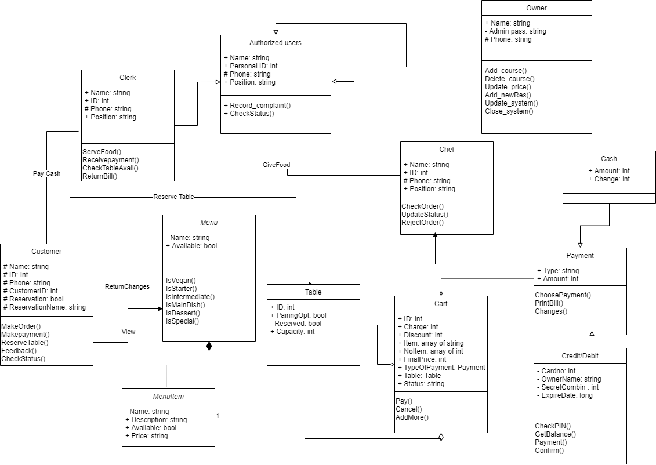

[Link to the diagram.](https://viewer.diagrams.net/?page-id=C5RBs43oDa-KdzZeNtuy&highlight=0000ff&edit=_blank&layers=1&nav=1&hide-pages=1#G137tRxU9NFXvCQelav6SM3Q9j6RO7ajNk)

# Task 3:

## Task 3.1:

For our system, we use theMVC or “Model-View-Controller”approach as there are many advantages of this approach compared with other approaches. Here’s how:

1. MVC’s 3 main components

Model: The Model component corresponds to all the data-related logic that the user works with. This can represent either the data that is being transferred between the View and Controller components or any other business logic-related data. For example, a Customer object will retrieve the customer information from the database, manipulate it and update its data back to the database or use it to render data.

View: The View component is used for all the UI logic of the application. For example, the Customer view will include all the UI components such as text boxes, dropdowns, etc. that the final user interacts with.

Controller: Controllers act as an interface between Model and View components to process all the business logic and incoming requests, manipulate data using the Model component and interact with the Views to render the final output. For example, the Customer controller will handle all the interactions and inputs from the Customer View and update the database using the Customer Model. The same controller will be used to view the Customer data.

Reasons why we choose MVC for our system?

Faster Development Process

MVC supports rapid and parallel development. MVC model allow separation between logic design and ux design, which make it possible that one programmer works on the view, one works on the controller transfer and the other can work on the controller to [create the business logic of the web application](https://www.brainvire.com/microsoft-enterprise-services/). Hence, the application developed using the MVC model can be completed three times faster than applications that are developed using other development patterns.

Ability To Provide Multiple Views

In the MVC Model, you can create multiple views for a model. Today, there is an increasing demand for new ways to access your application and for that MVC development is certainly a great solution. Moreover, in this method, code duplication is very limited because it separates data and business logic from the display.

Support For Asynchronous Loading

MVC supports integration with JS, TS or even Express.js, allowing asynchronous sync and rendering, providing a much faster lower loading time.

The Modification Does Not Affect The Entire Model

For any web application, the user interface tends to change more frequently to attract attention. Changing in small details like font, themes, or even icon sets is very common these days. With other models where there is blended logic in the render process, changing can be costly. Using MVC is not. Adding a new type of view is very easy in the MVC pattern because the Model part does not depend on the views part. Therefore, any changes in the Model will not affect the entire architecture.

MVC Model Returns The Data Without Formatting

MVC pattern returns data without applying any formatting. Hence, the same components can be used and called for use with almost no interface.

1. Specific description of MVC architectural pattern using diagram

<https://viewer.diagrams.net/?page-id=c4acf3e9-155e-7222-9cf6-157b1a14988f&highlight=0000ff&edit=_blank&layers=1&nav=1#G1JpoDzMLyCyRaqrDFEk9NFJEIWx0er9sQ>

View:

Include menu and cart, homepage, payment and billing pages.

The menu and cart receive a list of serving dishes from model and display them.

Homepage is a static website containing general information and promotion.

Payment is used for customers to input credit information.

Billing allows customers to have a brief look of the bill they will receive and the option to have it printed.

Model:

Include 4 main systems:

Payment system contains check PIN and balance and confirm transaction, allowing customers to know if the payment is successful or not; and export billing information to extract the id of the transaction if there is unwanted error later.

Notification system allows pushing the status of the order to customers, whether they are finished or cancelled by the chief; and later, if possible, an internal message board among personnel, as well as pushing promotion to customers through the notification board on the browser.

The order system allow personnel to update status of the order, add, remove some out of service courses, take the order into pending mode for reservation, log completed orders, respond to the view with availability of dishes customers order(some dishes just went out of ingredients) and price update for the owner.

The System component is the general settings: auto backup order pending and completed, record the feedback of customers, confirm promotion code entered by customers, and authenticate users, staff and owner account. Hence, the close and update method to close and backup data for backup, install fixes and update information.

Controller:

Main controllers control the moving around behaviors of customers, connect model and view as well as which type of account is the user(chief, clerks, owners or guests).

Payment sub controller allows customers to pay by cash or with credit card.

Order sub controller creates an object of items and sends it to model for checking.

## Task 3.2:

1. **Component diagram**

The implementation diagram we are going to model implementation details is component diagram.

Short description of component diagram: A component diagram, also known as a UML component diagram, describes the organization and wiring of the physical components in a system. Component diagrams are often drawn to help model implementation details and double-check that every aspect of the system's required functions is covered by planned development.

Basic Component Diagram Symbols and Notations

**Component**

A component is a logical unit block of the system, a slightly higher abstraction than classes. It is represented as a rectangle with a smaller rectangle in the upper right corner with tabs or the word written above the name of the component to help distinguish it from a class.

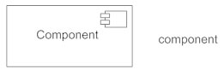

**Interface**

An interface (small circle or semi-circle on a stick) describes a group of operations used (required) or created (provided) by components. A full circle represents an interface created or provided by the component. A semi-circle represents a required interface, like a person's input.

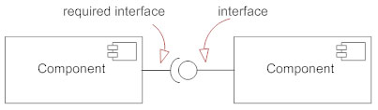

**Dependencies**

Draw dependencies among components using dashed arrows.

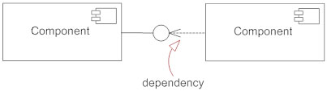

**Port**

Ports are represented using a square along the edge of the system or a component. A port is often used to help expose required and provided interfaces of a component.

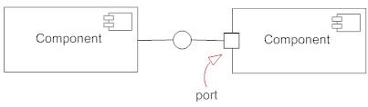

The reasons we choose component diagrams are:

* Component diagrams are very simple, standardized, and very easy to understand.
* It is also useful in representing the implementation of a system.
* These are very useful when you want to make a design of some device that contains an input-output socket.
* Use of reusable components also helps in reducing overall development cost.
* It is very easy to modify and update implementation without causing any other side effects.

However, component diagram has some drawbacks:

* They cannot be used for designing Software like web pages, applications, etc.
* It also requires sponsoring equipment and actuators for each and every component.

1. **Implementation**
2. **Order system**

The processed order takes in information of customers’ details, order entry from the shopping cart, food details, and payment details before being confirmed by the clerk and getting recorded in the order database.

*Figure 1: Order system Implementation Diagram*

1. **Payment system**

The customer can pay in two ways:

* Paying by credit card: the customer will make online payment through their bank account and the transaction is recorded into the customer database.
* Paying by cash: the app will notify the clerk to come to the customer’s dining table to receive cash and return the charge if any, the transaction will also be recorded in customer database.

*Figure 2: Payment System Implementation Diagram*

* The manager can modify the staff’s detail, menu entries like adding or removing food, modify price, and also change the current stock of the restaurant through the front page.

*Figure 3: Management system Implementation Diagram*

* The customer can view the food’s overview details like its name and price on the menu. Those details are extracted from the food’s detailed description in the food database.

*Figure 4: Skim menu Implementation Diagram*

## Changelog

18/9/2021: Context, requirement and use-case diagram first created.

23/9/2021: Update on the format and some relationship of use-case diagram.

7/10/2021: Update on the usecase diagram after the review.

10/10/2021: Change the relationship of class diagram.

15/10/2021: Created Architecture diagram of Server - Client.

18/10/2021: Discussed and chose the MVC model.

20/10/2021: Version 1 of Architecture diagram is created.

22/10/2021: Version 2 of Architecture modified.

## Reference

1. [Restaurant Orders (UML Class Diagram) - Software Ideas Modeler](https://www.softwareideas.net/a/378/Restaurant-Orders--UML-Class-Diagram-)
2. [OOAD - UML Basic Notations (tutorialspoint.com)](https://www.tutorialspoint.com/object_oriented_analysis_design/ooad_uml_basic_notation.htm)
3. [Complete Guide to Architecture Diagrams (edrawsoft.com)](https://www.edrawsoft.com/architecture-diagram.html)
4. [Step by step...: Model-View-Controller (MVC) pattern simple example (shulgadim.blogspot.com)](https://shulgadim.blogspot.com/2012/01/model-view-controller-mvc-pattern_13.html)
5. [A Java Model View Controller example (Part 1) | alvinalexander.com](https://alvinalexander.com/ooa-ood/java-model-view-controller-mvc-example-1/)
6. [AWS Architecture Diagram Examples to Quickly Create AWS Architectures (creately.com)](https://creately.com/blog/diagrams/aws-templates-for-architecture-diagrams/)
7. [Build a Complete MVC Website With ExpressJS (tutsplus.com)](https://code.tutsplus.com/tutorials/build-a-complete-mvc-website-with-expressjs--net-34168)